West Lochaber DMG

WEST SIDE POPULATION OBSERVATIONS

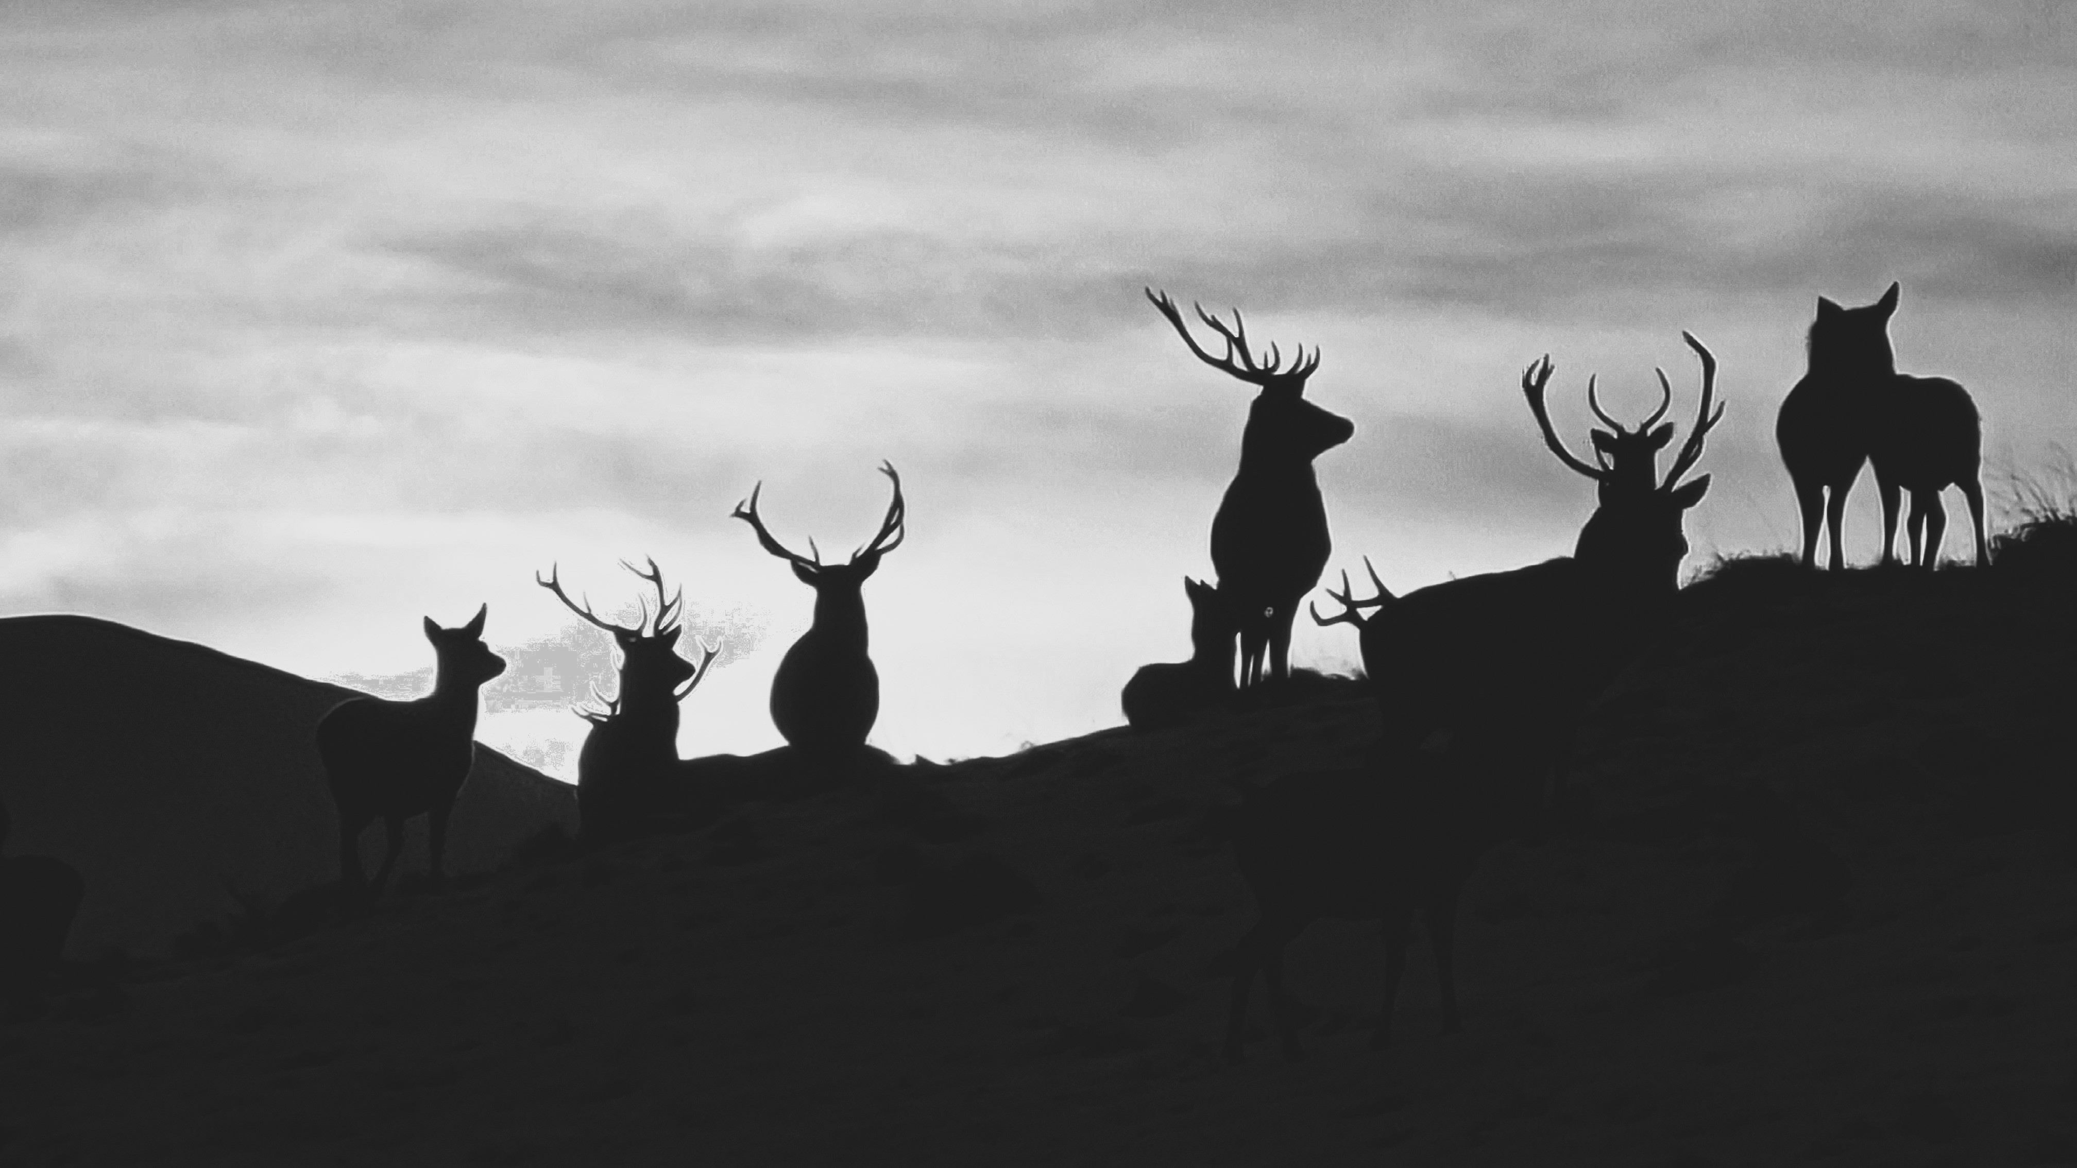
Photo: Ross Dakers

Victor Clements: Native Woodland Advice
Mamie’s Cottage, Taybridge Terrace, Aberfeldy, Perthshire
PH15 2BS
Office: 01887 829361 Mobile: 07787 520987 Email: victor@nativewoods.co.uk

The Native Woods Co-operative (Scotland) Ltd is a non profit distributing organisation dedicated to managing and expanding Scotland’s native woodlands. We offer specialist advice and management services to landowners and agents throughout the country.

Background
This short report is provided for WLDMG members on the possible population dynamics within the west side of the DMG area, west of Glenfinnan.

Population modelling suggests that current culls would not be able to keep the current population in check, and that deer numbers on that side may be increasing steadily, unless there is a source of loss which is not being accounted for. It is not clear to me which of these scenarios is likely to be the case.

The significant natural heritage consideration in this part of the DMG is the Glen Beasdale SSSI/ SAC site.

The purpose of this report is to try and tease out the dynamics within the west side of WLDMG as a whole.

Deer count data
The last independent deer count in WLDMG area was in spring 2018, and although foot counts have taken place since then, this is likely to be the best data set available regarding populations.

Property | Ha | Stags | Hinds | Calves | Total | Density
ARDNISH | 1444 | 100 | 93 | 35 | 228 | 16
ARISAIG | 3430 | 201 | 408 | 136 | 745 | 22
GLENMAMIE ESTATE | 1691 | 31 | 137 | 44 | 212 | 13
MEOBLE | 8620 | 383 | 891 | 265 | 1539 | 18
RANACHAN | 1547 | 65 | 158 | 48 | 271 | 18
SCAMADALE | 496 | 44 | 12 | 3 | 59 | 12
Total | 17228 | 824 | 1699 | 531 | 3054 | 18

There are a couple of notable things here.

Firstly, the deer density at 18 per sq km is very high for the western Highlands, and is actually much higher than the east of the DMG area (12 per sq km). At a deer density of this size, density dependent factors that constrain population growth are likely to be in evidence. Ie Higher mortality, greater absorption rates, lower recruitment etc. Given the very wet and inhospitable nature of much of the ground, a deer density of this type is a bit of a red flag from a number of points of view.

The hind population outnumbers the stags by more than 2:1, not unusual, but unnecessary where the stag requirement is actually fairly low.

There has been quite a lot of feedback on these figures, noting particularly that the 2018 count was taken just after the “Beast from the East”, and that there was likely to have been a significant drift of deer westwards on to more benign ground. However, it needs to be noted that the whole western side was at an average density of 18 deer per sq km, and the 2018 count showed a fairly stable population from Glenfinnan eastwards, in line with their expectations. If deer came in to West Lochaber after the storm, they can only have came from adjacent DMG areas, which doesn’t seem that likely. Certainly, the previous deer management plan thought that movement between DMG areas was fairly minimal, and no-one raised the prospect when drawing up this plan.

We will however turn to modelling below.

Deer demand
Analysis of questionnaires show that the stated demand for stags is 103 animals across these estates, and the demand for sporting hinds is 107 animals. Actual culled stags average around 85 however, and hinds about 160 animals. This requirement is very low for a population of over 3000 animals.

Population modelling
A series of four population models are set out in the spreadsheet West Population models. The models are designed to show different aspects of the current situation.

Model 1: West side population check from 2018
This model takes the population from spring 2018, factors in the actual culls since then and estimated recruitment and mortality, and projects forward to the present.

Ignore the blue lines for now.

The model suggests that with current culls, the population should still be increasing, with a population density of 26 per sq km in spring 2023. It is highly unlikely that this could actually be the case, with density dependent losses almost certainly having kicked in long before this point.

However, it could well be/ probably is the case that the current population is still higher than the 18 deer per sq km counted in 2018. For example, the 2023 count suggests that the deer desnity on the eastern side has went up, so it is certainly possible that it could have in the west too.

Model 2: West side Adjusted for Stability
The deer density on the eastern side of the group appears to be relatively stable, and this seems to be a plausible hypothesis there.

We cannot have the same confidence here, but if the population in the west was also stable, what additional losses would be required to maintain a steady population, above the recorded culls?

This model suggests there would need to be an annual loss of about 158 stags and 75 hinds for the western population not to be expanding quickly, as per Model 1.

Such losses could come from a number of sources:

- Emmigration to another area
- Unrecorded poaching
- Unrecorded road or train deaths
- Higher mortality than the default 2% for hinds and stags, and 6% for calves
- Some other density dependent factor such as lower recruitment or higher absorption rates, particularly of stag calves.

The stag loss is very significant, being about 65 percent higher than the annual average cull. The hind loss is more modest, being about 50% of the average cull, but is still significant.

At high deer densities, it is likely that both emmigration and deer density dependent mortality or loss will be significant. Part of the answer, undoubtedly, is to lower the deer density.

Model 3: Ideal Population
The sporting stag and hind demand on the western side of the DMG is in fact very modest, with approx 100 stags and 100 hinds being needed annually to satisfy demand.

Model 3 suggests that such a demand can be met by a much lower deer population of around 750 stags and 750 hinds, giving an overall population density of 10.2 per sq km.

So, in theory at least, the 2018 deer population could be reduced by 1300 animals without any compromize to people’s requirements.

Such a reduction would almost certainly reduce any density dependent or exacerbated losses, as well as reducing net emmigration.

The only question then would be whether road/ train losses are significant, or whether there is significant poaching in the area, either from the roadside, or perhaps from the coast.

If these factors are not thought to be important, then a very signiifcant deer reduction cull is required, and that could be implemented without detriment to sporting interests.

What might such a cull look like?

Model 4: West side reduce to 10 per sq km
This model assumes that the 2018 counted population is what exists in spring 2023, but it could well be higher than this.

We assume that half the potential losses are taking place, but if this is not the case, then these figures need to be added to the annual cull.

The figures suggest annual culls of 180 stags and 360 hinds would be required for three years, plus a slightly reduced cull the following year to bring the population down to c 10 per sq km over four years. This is twice the average stag cull, and more than twice the annual average hind hill.

This would be a very significant undertaking indeed, and a big operation for everyone on the western sde of the group.

Unknowns
There are a number of unknowns about the western side of the group, not least that the current population may well be greater than 2018, or that signiicant annual losses may well be occurring via accidents or poaching, or significant emmigration to other areas.

However, the difference between the population that seems to exist and the population that should be required is so great that much larger culls would appear to be easily justifiable, subject to a helicopter check within the next 2-3 years.

Glen Beasdale SSSI/ SAC
10 deer per sq km is almost certainly not going to bring this site back in to favourable condition, but it seems to me that the priority across this area is getting the deer density back to this level first over 3-4 years. There are a number of things that can be done around the SSSI/ SAC to help form a strategic plan, including opening up established birch woods, and focusing control efforts within the main part of the designated site, as well as setting up a monitoring system. Arisaig Estte are cautious about opening up more birch woodlands for fear of drawing deer closer to the road and railway.

It is also possible that during this period that a suitable support mechanism for delivering targeted management within the designated site will then exist. At the moment, it clearly does not exist, but a package of measures is supposed to be in place by 2026.

It therefore seems to me that achieving this wider deer reduction is the priority, and we have to hope that the required mechanism for targeted input around Glen Beasdale is then available.

Which is the best count information to use?

There have been 2 X footcounts since 2018, in 2021 and in 2023. The 2023 count only had partial coverage, and therefore cannot really be used.

The results of the 2021 count are summarized below, and compared to 2018. All the properties except for Meoble are broadly comparable to 2018, which has only half the 2018 numbers.

2021 West Count |  | 2021 |  |  |  | 2018
 | Stags | Hinds | Calves | Total | Stags | Hinds | Calves | Total
Ardnish | 79 | 103 | 21 | 203 | 100 | 93 | 35 | 228
Arisaig | 145 | 302 | 123 | 570 | 201 | 408 | 136 | 745
Glenfinnan | 106 | 216 | 84 | 406 | 100 | 235 | 63 | 398
Kinloid |  |  |  | 0 | 13 | 20 | 5 | 38
Glenmamie | 38 | 168 | 62 | 268 | 31 | 137 | 44 | 212
Meoble | 204 | 461 | 173 | 838 | 383 | 891 | 265 | 1539
Ranachan | 36 | 138 | 42 | 216 | 65 | 158 | 48 | 271
Scamadale | 22 | 63 | 20 | 105 | 44 | 12 | 3 | 59
Totals | 630 | 1451 | 525 | 2606 | 937 | 1954 | 599 | 3490

Is the Meoble result an under- count, or is it real? If it was real, that would give a population of c 15 deer per sq km across the west side as a whole.

Lets say, for the sake of argument, that this was the actual count in 2018 after any temporary immigration had been taken account of ( c 800 animals).

WEST SIDE pop check with lower starting density
 | Stags | Hinds | Calves | Total | Density
2018 Spring Population | 630 | 1451 | 525 | 2606 | 15.1
2018 Summer Population | 893 | 1714 | 531 | 3137 | 18.2
2018/19 Actual Cull | 71 | 156 | 44 | 271
Est Cull elsewhere | 0 | 0 | 0 | 0
2019 Mortality | 18 | 34 | 32 | 84
2019 Spring Population | 804 | 1523 | 455 | 2782 | 16.1
2019 Summer Population | 1031 | 1751 | 578 | 3360 | 19.5
2019/20 Actual Cull | 99 | 163 | 43 | 305
Est Cull elsewhere | 0 | 0 | 0 | 0
2020 Mortality | 21 | 35 | 35 | 90
2020 Spring Population | 912 | 1553 | 500 | 2965 | 17.2
2020 Summer Population | 1162 | 1803 | 595 | 3560 | 20.7
2020/21 Actual Cull | 81 | 180 | 48 | 309
Est Cull elsewhere | 0 | 0 | 0 | 0
2021 Mortality | 23 | 36 | 36 | 95
2021 Spring Population | 1058 | 1587 | 511 | 3156 | 18.3
2021 Summer Population | 1313 | 1843 | 608 | 3764 | 21.8
2021/22 Actual Cull | 86 | 151 | 59 | 296
Est Cull elsewhere | 0 | 0 | 0 | 0
2022 Mortality | 26 | 37 | 36 | 100
2022 Spring Population | 1201 | 1655 | 513 | 3368 | 19.6
2022 Summer Population | 1457 | 1911 | 631 | 3999 | 23.2
REPEAT 2021/22 cull | 86 | 151 | 59 | 296
Est Cull elsewhere | 0 | 0 | 0 | 0
2023 Mortality | 29 | 38 | 38 | 105
2023 Spring Population | 1342 | 1722 | 534 | 3597 | 20.9
2023 Summer Population | 1609 | 1989 | 656 | 4254 | 24.7
REPEAT 2021/22 cull | 86 | 151 | 59 | 296
Est Cull elsewhere | 0 | 0 | 0 | 0
2024 Mortality | 32 | 40 | 39 | 111
2024 Spring Population | 1491 | 1798 | 558 | 3846 | 22.3

Starting with a lower density in 2018 would still potentially be giving over 20 per sq km today.

Even if we used the 2021 figures in the population model from 2021, the density today would be c 17.5 per sq km when projected forwards, given the estimated culls there have been since then.

2021 Spring Population | 630 | 1451 | 525 | 2606 | 15.1
2021 Summer Population | 893 | 1714 | 565 | 3171 | 18.4
2021/22 Actual Cull | 86 | 151 | 59 | 296
Est Cull elsewhere | 0 | 0 | 0 | 0
2022 Mortality | 18 | 34 | 34 | 86
2022 Spring Population | 789 | 1528 | 473 | 2789 | 16.2
2022 Summer Population | 1025 | 1764 | 582 | 3372 | 19.6
REPEAT 2021/22 cull | 86 | 151 | 59 | 296
Est Cull elsewhere | 0 | 0 | 0 | 0
2023 Mortality | 20 | 35 | 35 | 91
2023 Spring Population | 918 | 1578 | 488 | 2985 | 17.3

It seems to me that whatever your assumptions, the most likely scenario is that in 2023, there is a density of at least 18 deer per sq km in the west of the DMG, and probably more than this. The chances of the population density being lower is very small indeed, unless there have been a couple of years of much higher mortality.

There is mention in the previous plan of periodic episodes of high mortality in the west of the group, which will almost certainly be density dependent. So, if 2 X DMP authors can form the same view independently of one another, then there is something here that needs to be addressed, and addressed most effectively by having a lower population in line with actual demands.

It is suggested therefore that Model 4 is the one to be adopted by the west side of WLDMG from 2023/ 24. There are two assumptions in this which give benefit of the doubt to the DMG, (1) That the population is not higher than 18 per sq km, and (2) That a higher level of mortality/ loss exists which is factored in to the model.

If this loss does not exist, or if the density is higher than 18 per sq km, then obviously reduction culls would need to be higher. A helicopter count is needed to check, but the suggested cull should begin in 2023/ 24.

